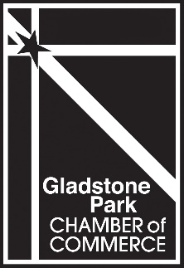
The Gladstone Park
Chamber of Commerce

Put the Resources of Our Members
Behind Building Your Business

Join the Gladstone Park Chamber Today!
Website Directory Listing
Reduced Price Advertising
Business After-Hours Opportunities
Social Media Support
Monthly Networking Events
Inclusion in the Annual Community Guide
Welcome Bag Program
Special Member Discounts
Business Name:
___________________________________________________________________

Business Address:
___________________________________________________________________

Mailing Address (if different from physical address)
___________________________________________________________________

Owner Name: _________________ Phone: __________ Email: _______________

Contact Name: _________________ Phone: ___________ Email: ______________

Business E-mail (for public listing): ______________________________________

Website: ____________________________________________________________

Type of Business (Business Category): _____________

Number of Employees: __________
Please complete this application remit payment to:
Gladstone Park Chamber of Commerce, 6348 N Milwaukee Ave, PMB 318, Chicago, IL 60646

1-10 Employees $150
11 or more Employees $250
Non-Profit/Residents $60
Newsletter/Website Advertising $100

If you have any questions please feel free to call Cathy, Executive Director at
(773)756-6206 or email at Cathy@gladstoneparkchamber.com

